T-matrix “BASE-link 1”

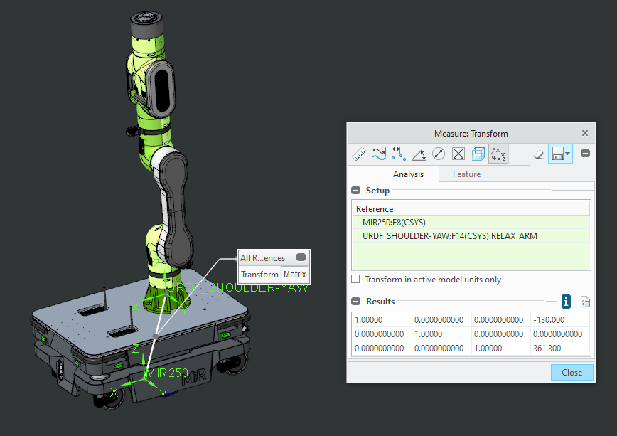

1.00000 0.0000000000 0.0000000000 -130.000

0.0000000000 1.00000 0.0000000000 0.0000000000

0.0000000000 0.0000000000 1.00000 361.300

T-matrix “link 1-link 2”

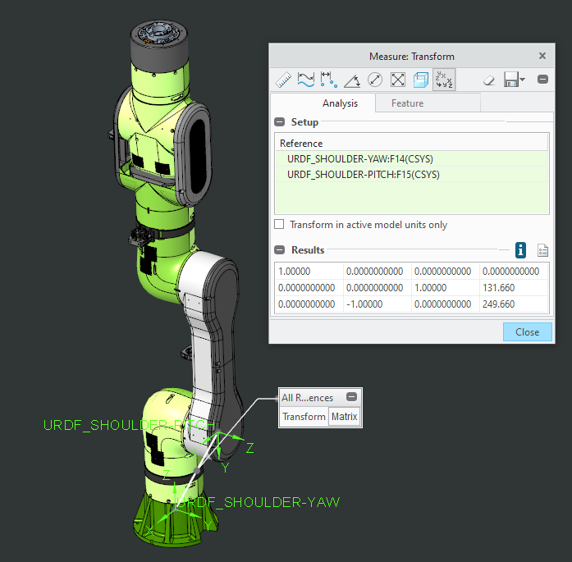

1.00000 0.0000000000 0.0000000000 0.0000000000

0.0000000000 0.0000000000 1.00000 131.660

0.0000000000 -1.00000 0.0000000000 249.660

T-matrix “link 2-link 3”

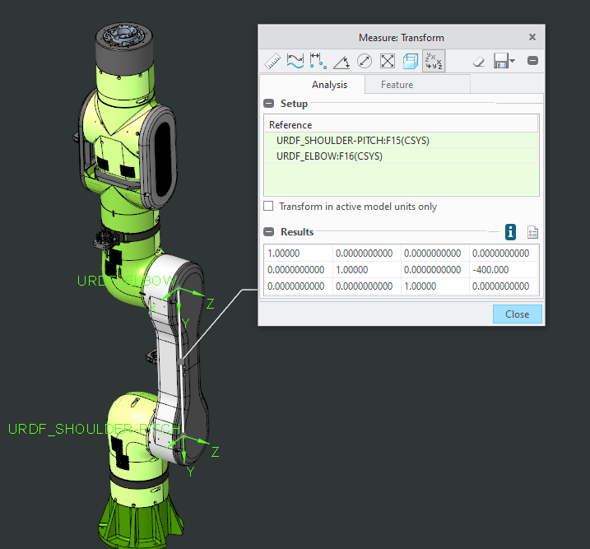1.00000 0.0000000000 0.0000000000 0.0000000000

0.0000000000 1.00000 0.0000000000 -400.000

0.0000000000 0.0000000000 1.00000 0.0000000000

T-matrix “link 3-link 4”

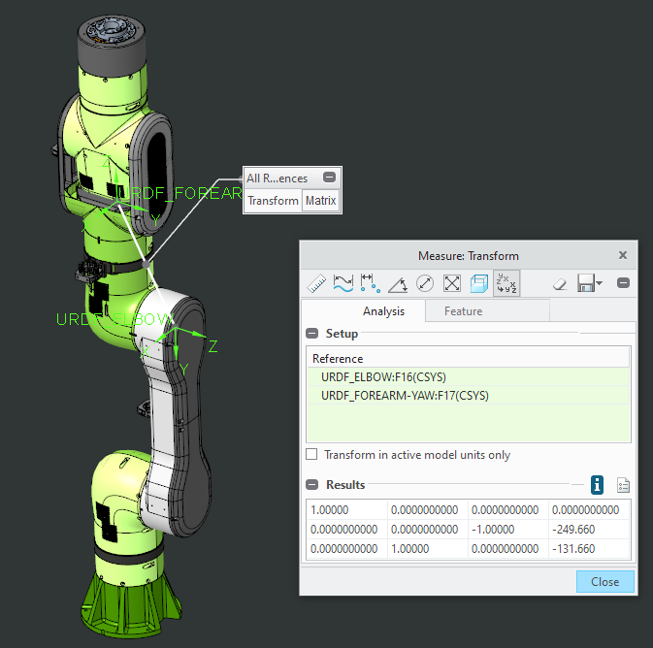1.00000 0.0000000000 0.0000000000 0.0000000000

0.0000000000 0.0000000000 -1.00000 -249.660

0.0000000000 1.00000 0.0000000000 -131.660

T-matrix “link 4-link 5”

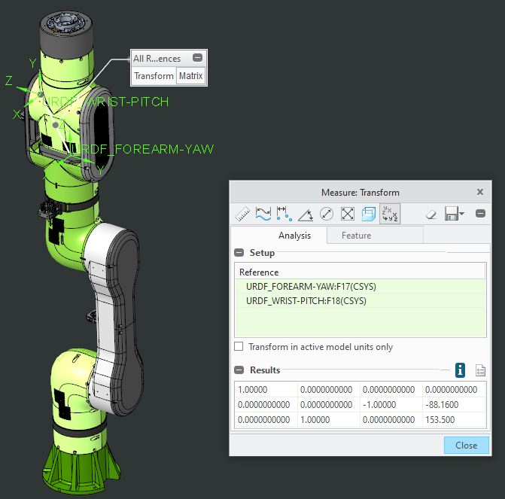1.00000 0.0000000000 0.0000000000 0.0000000000

0.0000000000 0.0000000000 -1.00000 -88.1600

0.0000000000 1.00000 0.0000000000 153.500

T-matrix “link 5-link 6”

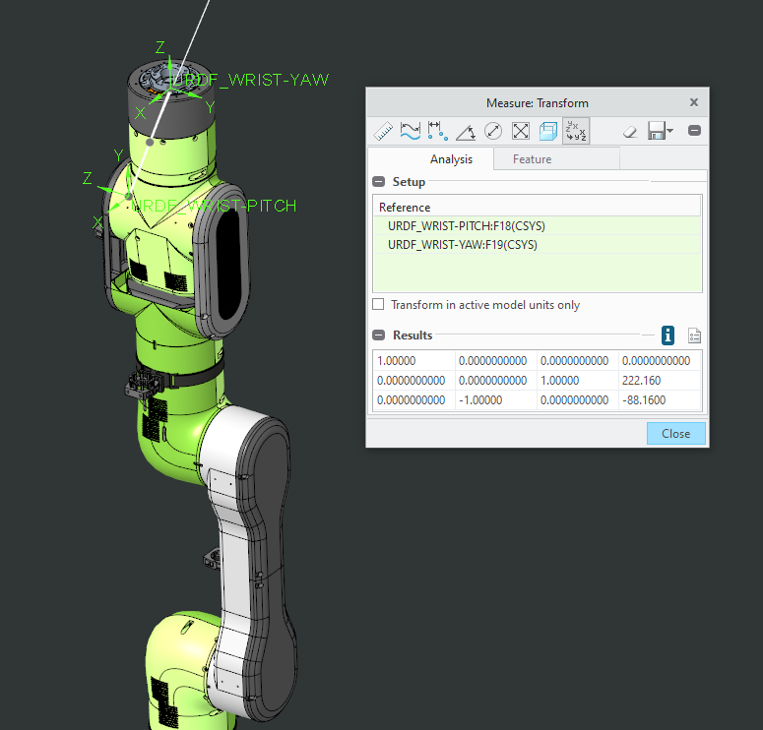1.00000 0.0000000000 0.0000000000 0.0000000000

0.0000000000 0.0000000000 1.00000 222.160

0.0000000000 -1.00000 0.0000000000 -88.1600

T-matrix “link 6-END-Effector”

